Smart cities

Living in the future – now

VIENNA – In late 2017 Vienna was awarded as the smartest city on a list of over 80 competitors around the globe. It was highly praised for its innovative ideas and support of “green projects”. Frankly, this is something Austria can be proud of, however not a reason to relax, and, because there are a lot of misconceptions concerning this topic, we all need to inform ourselves, as well as take a daring look into the future of living.

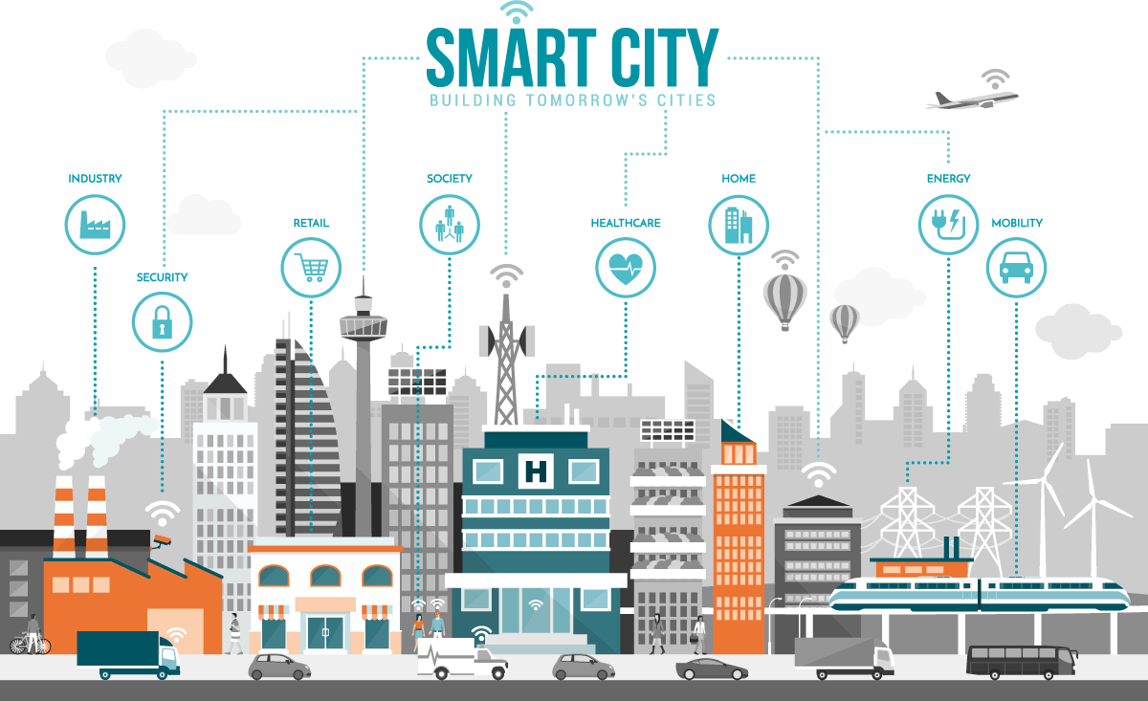

**About a truly smart city**

Experts distinguish two ways a smart city can occur. The first one is the more obvious, and arguably the less complicated one. Just build a new city. If you create a city from scratch, city planners may design it in an efficient way all around. From public transport, solar and wind farms, smart public housing to even vertical farming facilities, the options are endless.

A great example of this is Songdo City in South Korea. A whole city was stamped out of ground in just over a decade. It utilizes the most modern technology, starting with computers that are built into homes and public spaces. One frequently used example is the possibility to control your whole apartment with one click, and as a result reduce energy consumption by micromanaging what you truly need. In recognition of their work Songdo City is now home to the United Nations Green Climate Fund.

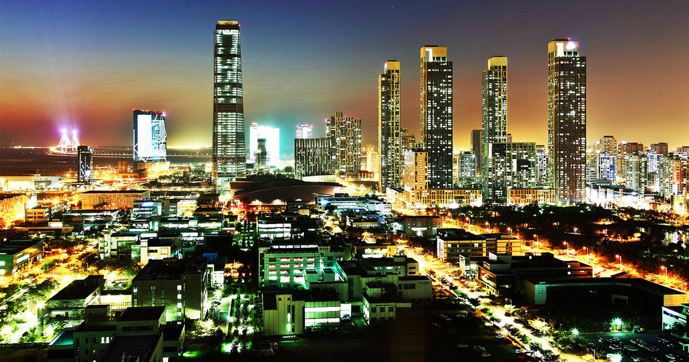

**Smart city wannabe**

However, the second kind of smart cities is the more common one, an older city, already a metropolitan area with millions of residents being outfitted with modern-day technology. For example, in Berlin scientists integrated a system which helps visually impaired persons orient themselves at train stations, in malls and at public agencies.



**Orwell´s 2018**

Not everything that glitters is gold. Already we are seeing some worrying trends which are justified as “smart city”. Oppressive regimes like Russia have started to develop their cities not to benefit their citizens or to help reduce the impact that metropolitans have on the environment, but to monitor their residents. One of those highly problematic ideas is currently being implemented in China, whose government is equipping their cities with CCTV cameras and is using this footage together with all other data they are mining to rate people’s behavior.

Smart cities are a realistic approach to solve a lot of humanities problems, if it´s done in good faith. So, my plea to all reading this is get engaged, decide for yourself how you want your environment to change and do not let this important decision be made by someone else.

Sources:

<http://www.faz.net/aktuell/wirtschaft/wohnen/smart-cities-die-vernetzte-stadt-14398252.html?printPagedArticle=true#pageIndex_0>

<https://www.rolandberger.com/de/press/Smart-City-Index-Wien-international-auf-Platz-Eins-f%C3%BCr-den-ganzheitlichen-Ans.html>

<https://www.wien.gv.at/politik/international/vergleich/smart-city-index.html>

<https://www.bbc.com/news/technology-23757738>